Long Term Planning

* What follows on the next couple of pages are the planning processes I had for one of my units.

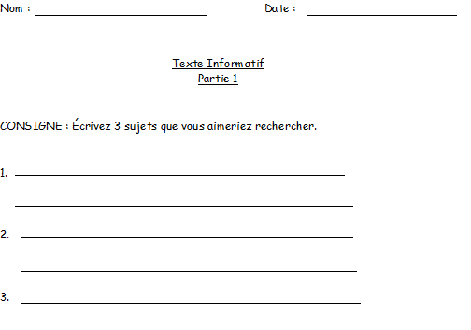

**Part 1:** Choose 3 possible topics that you would like to research. I gave them the option to choose so it would be relevant to them.

*\*The QEP states that in cycle 3 students need to know how to write an informative text. This is where this unit started from. From that I knew I needed to assess them on if they were able to produce an informative text.*

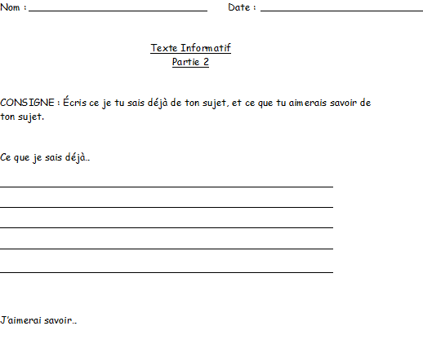

**Part 2:** Once I approved their topic, they had to write what they already knew about it, and what they would like to know more about.

\**After approving the topic of their choice, I knew the first lesson had to be very specific. I wanted them to narrow down what they already knew from what they wanted to know (this was also a form of pre assessment).*

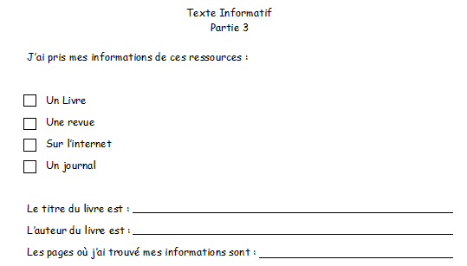

**Part 3:** Once they started their research I wanted to know where they found their information.

*\*Lesson 3 was carried out in the computer lab.* *I wanted to make sure everyone was able to use a computer.*

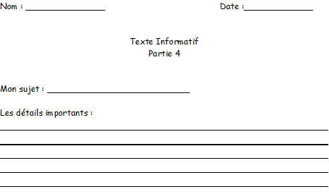

**Part 4:** For this lesson the students had to find the important details of their topic.

*\*It is really hard for students to pick out important details from secondary details. So a whole lesson was dedicated to figuring out what a main idea was.*

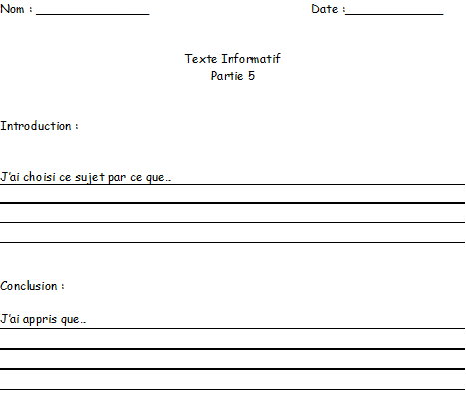

**Part 5:** In this lesson, my students had to write an introduction and a conclusion.

*\*This lesson was carried out in class as well.*

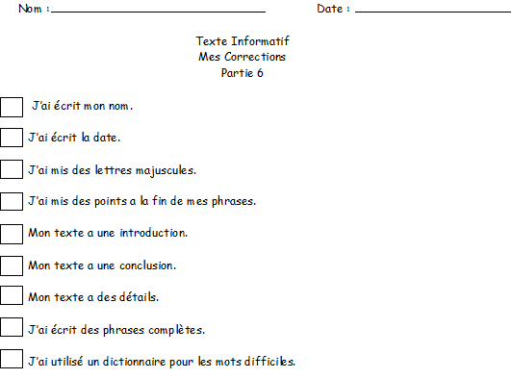

**Part 6:** The last part for the students after they wrote the good copy was to verify that everything was included. This is what they would be evaluated on.

*\*The students spent a class editing their work for their final project.*